The European ATM Master Plan 2012 wins prestigious IHS Jane’s ATC Award

Madrid, 11 February 2013 - SESAR Joint Undertaking (SESAR JU) and its Partners have been awarded Winner of the European ATM Award by IHS Jane’s ATC Awards for the delivery of the European ATM Master Plan 2012, a work led by Eurocontrol with the active contribution of all SESAR members.

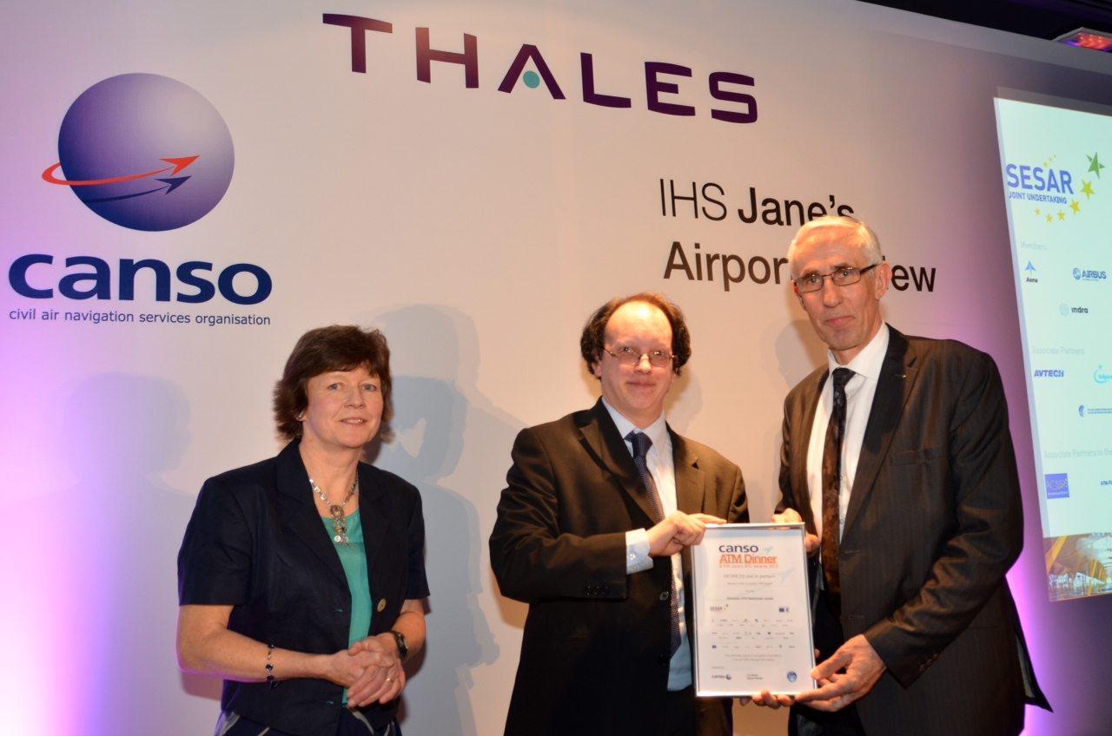
The European ATM Master Plan is the roadmap driving the modernisation of the Air Traffic Management (ATM) and governing the transition from SESAR to deployment. It is the basis for the new generation of European systems for 2030 that will help achieve more “sustainable and performing aviation” in Europe.
The plan contains roadmaps for the operational and technological changes required from all stakeholders. The purpose is to achieve the performance objectives set by the Single European Sky (SES). It provides the basis for the timely coordinated and efficient deployment of new technologies and procedures, whilst ensuring alignment with ICAO’s aviation system block upgrades (ASBU) for global interoperability and synchronisation.
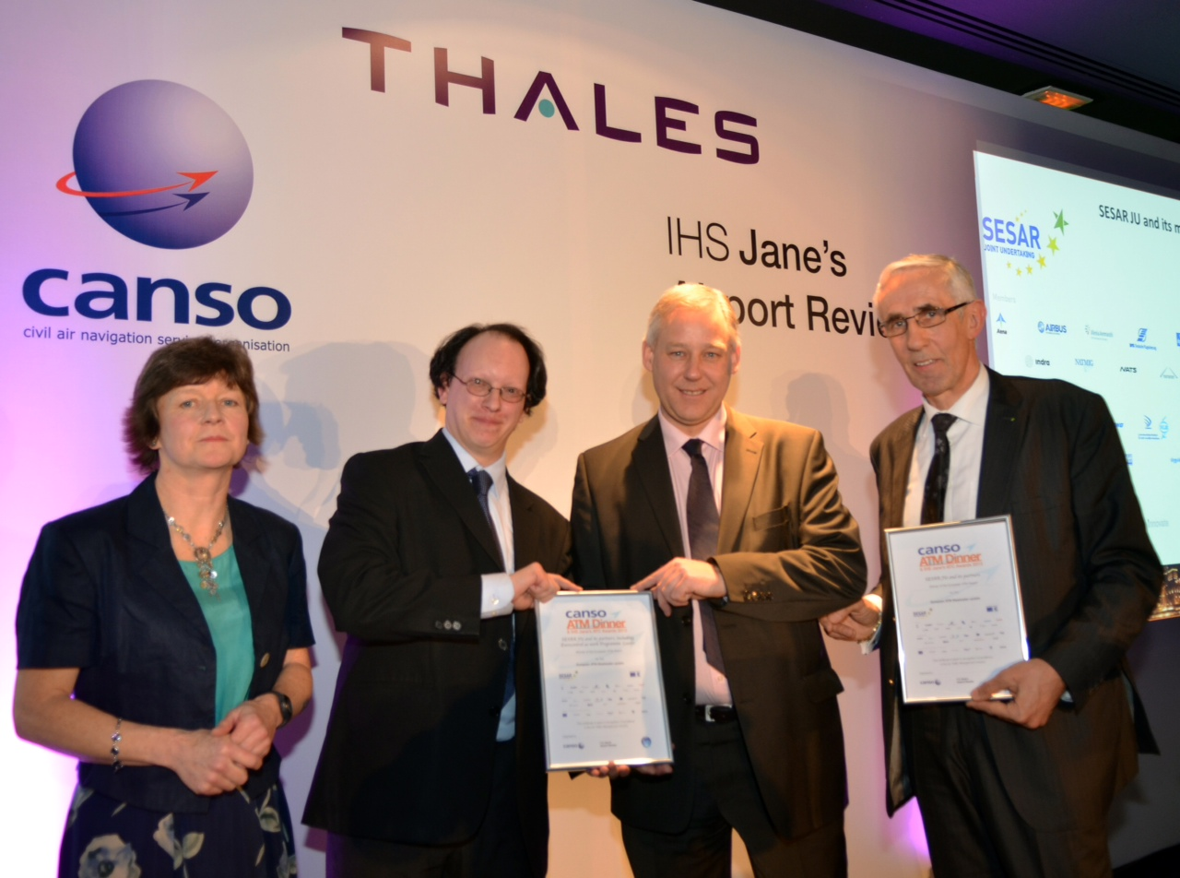
The success of the Master Plan is the result of more than a year of collaborative work by all the SESAR JU’s partners (airspace users, ANSPs, airport operators, military, network manager and staff associations). It demonstrates the relevance of SESAR JU business model for achieving concrete results.
The IHS Jane’s ATC awards are an opportunity to celebrate the technical developments, product innovation, safety and efficiency initiatives that result in real savings for airspace users.

# # # # # # #

The SESAR programme is the operational and technological solution to the challenges of upgrading European air traffic. The aim of the SESAR Joint Undertaking is to modernise European air traffic management by coordinating and concentrating all relevant research and development efforts in the European Union. Partnership, sustainability and user-drive are key concepts of the SESAR Joint Undertaking. Founded by the European Commission, Eurocontrol and the following fifteen member companies: AENA, Airbus, Alenia Aermacchi, DFS, DSNA, ENAV, Frequentis, Honeywell, Indra, NATMIG, NATS (En Route) Limited, NORACON, SEAC, SELEX Sistemi Integrati and Thales.
For more information, contact Nathalie Oghlian: Nathalie.oghlian@sesarju.eu
Visit www.sesarju.eu

